System Analysis and Design Report
This section discusses the elements of project management pertaining to the Fleet and Delivery Management System, including cost estimation and project scheduling, specifically focusing on the work breakdown structure and Gantt chart. It highlights issues that necessitate careful consideration.

Project Cost Estimate
We employed a technique known as Bottom-up estimation, where each item was assessed individually according to the specific tools, services, and market rates necessary, subsequently compiled into category tools. This approach was adopted because the project scope was distinctly outlined during the proposal phase, enabling each element to be priced with a high degree of accuracy. (Rose, 2013)
Item | Estimated Cost (AUD) | Notes
WordPress, ACF, GitHub, LocalWP | 0$ | Open-Source / free-tier tools Sufficient for given scope
Hosting(staging) | 0$ - 10$/month | Local Development environment Preferred.
Domain name | 10$-20$ | One-time, only if a public demo link is required.
Test/dummy data creation | 0$ | Raw data, no live data is used.
Contingency | 10-15$ | Buffer on direct total cost
Total Cost | 25$-45$ | Excludes Labour

Although the time invested by the project team is considered unpaid academic work, the labor was also compared to actual Australian WordPress developer rates to reflect cost-awareness. Junior level rates are reported to range from around $32 per hour to between $50 and $80 per hour. Freelance rates, on the other hand, are reported to be between $80 and $100 per hour. By using the junior developer benchmark as the closest approximation to the experience level of a student team, and estimating a total of 200 person-hours over four weeks, the notional commercial value of the work is approximately between $10,000 and $16,000. This amount is mentioned solely to illustrate cost-awareness, as no real payment is made. (Glassdoor 2026) (Codementor 2026)
The project's overall cost is minimal since it utilizes entirely free and open-source tools and operates within a non-production hosting environment. The crucial aspect to consider is the development time, which will be elaborated upon in the schedule presented below.

Project Schedule
The project schedule for the Fleet and Delivery management system integrates multiple sections, and it is specifically designed for a four-week timeframe for academic purposes. This schedule is illustrated through the Work Breakdown Structure (WBS) and a Gantt chart, which visually represent task durations, sequencing, and overlaps within the four-week period. The initial phase encompasses planning and environment setup, which includes the installation of WordPress and the creation of data models for orders, drivers, customers, and complaints. Following this, the development of the driver portal and the customer complaint page will be developed as distinct modules, while the admin dashboard will be created to manage driver assignments. The subsequent figure will elaborate on the Work Breakdown Structure and Gantt chart. ((Anthropic 2026)).

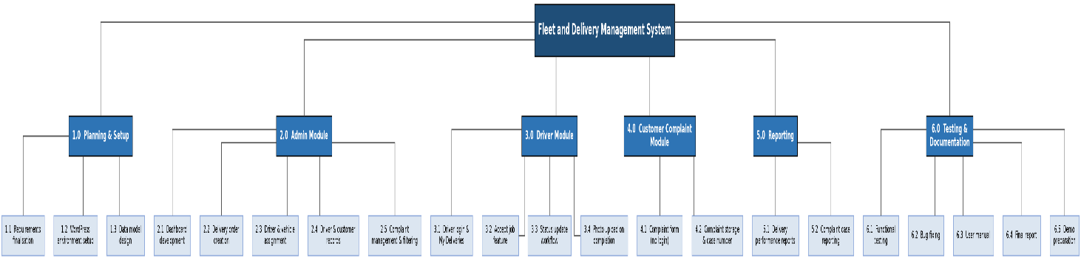

Fig 1

Work Breakdown Structure (WBS)
📦 Fleet and Delivery Management System
├── 1.0 Planning & Setup
│ ├── 1.1 Requirements finalization
│ ├── 1.2 WordPress environment setup
│ └── 1.3 Data model design
├── 2.0 Admin Module
│ ├── 2.1 Dashboard development
│ ├── 2.2 Delivery order creation
│ ├── 2.3 Driver & vehicle assignment
│ ├── 2.4 Driver & customer records
│ └── 2.5 Complaint management & filtering
├── 3.0 Driver Module
│ ├── 3.1 Driver login & My Deliveries
│ ├── 3.2 Accept job feature
│ ├── 3.3 Status update workflow
│ └── 3.4 Photo upload on completion
├── 4.0 Customer Complaint Module
│ ├── 4.1 Complaint form (no login)
│ └── 4.2 Complaint storage & case number
├── 5.0 Reporting
│ ├── 5.1 Delivery performance reports
│ └── 5.2 Complaint case reporting
└── 6.0 Testing & Documentation
├── 6.1 Functional testing
├── 6.2 Bug fixing
├── 6.3 User manual
├── 6.4 Final report
└── 6.5 Demo preparation

Gantt chart
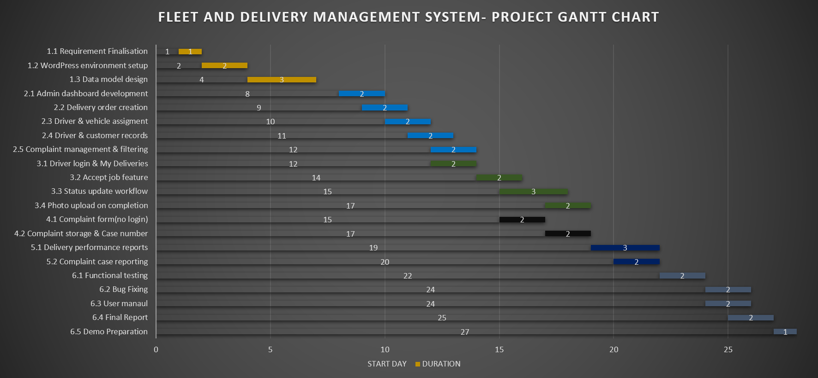

Fig 2

The Gantt chart presented below illustrates the Admin Dashboard and Driver Login module (Phase 2 – Phase 3) operating partially in parallel during Weeks 2 and 3. This arrangement demonstrates the project’s team-based delivery framework: with five team members at their disposal, independent modules were planned to run concurrently instead of following a strictly sequential order, thereby facilitating the completion of the entire project within the four-week limitation outlined in the project Assumptions and Constraints.

Issues Needing Consideration
The process of identifying risks for this project was based on recognized literature pertaining to IT project risks, rather than relying on a disorganized list. This approach aligns with the PMBOK risk categories, which include scope, schedule, resource, and technical risks. (Guinhouya, 2023) (Rose, 2013)

Issues | Relevance to This Project | Justification /Mitigation
Time constraint vs Quality | Four-week window limits the depth of testing possible | The compressed testing phase of the Gantt chart (days 22-28) directly reflects this, as it is mitigated by prioritizing essential user flows, such as order creation, assignment, and delivery, over less critical edge cases.
Scope creep | The scope has expanded once during the team's drafting process (the addition of complaint filtering and case numbers was made after the initial proposal draft), demonstrating internal refinement among the five team members instead of external supervisor feedback, given that no formal review or consultation with the supervisor has been conducted at this stage. Scope creep is recognized as a common IT project risk without any external stakeholder’s pressure. (Khan, S, Saher, N & Yunis, MS 2019) | This issue can be alleviated by securing the project scope within the team prior to reaching the next milestone and documenting additional suggestions as prospective tasks instead of integrating them into the current four-week development cycle.
Team Skill variance | A five-member student group with diverse backgrounds in WordPress proficiency. | Tasks were assigned according to the corresponding skill levels within the Work Breakdown Structure (WBS), along with conducting code reviews on intricate modules such as complaint filtering and photo upload.
No Production cutover | System will be demonstrated academically, not deployed live for GoPeople | Clearly articulated as an academic prototype within the assumptions section, there is no genuine risk of cutover.
Dummy data limitation | Testing is based on synthetic data instead of actual operational data from GoPeople. | It may not reveal all actual edge cases encountered in the real world; this can be alleviated by creating diverse test scenarios such as failed deliveries, duplicate complaints, and unassigned jobs.
Technical/Platform limitation | WordPress offers less flexibility compared to custom-developed software when it comes to handling complex logic. | In alignment with the Constraints section; alleviated by utilizing well-supported plugins (ACF) instead of extensive custom PHP development when feasible.

This systematic method for addressing risk, based on established categories such as scope, schedule, resources, and technical risk (Project Management Institute), facilitates more dependable planning compared to an unstructured list of issues. Furthermore, each mitigation strategy is directly linked to a decision that has already been documented in other sections of this report, including the locked scope baseline, Gantt chart testing allocation, and WBS task assignment. (Kutsch, 2009)

References
Kutsch, E., & Hall, M. (2009). The rational choice of not applying project risk management in information technology projects. Project Management Journal, 40(3), 72–81. https://doi.org/10.1002/pmj.20112
Rose, K. H. (2013). A guide to the project management body of knowledge (PMBOK guide) fifth edition. Project Management Journal, 44(3), e1–e1. https://doi.org/10.1002/pmj.21345
Khan, S., Saher, N., & Sohail Yunis, M. (2019). Project planning, project success and project risk. Global Social Sciences Review, IV(I), 219–225. https://doi.org/10.31703/gssr.2019(iv-i).29
Guinhouya, K. A. (2023). Bayesian networks in project management: A scoping review. Expert Systems with Applications, 214, 119214. https://doi.org/10.1016/j.eswa.2022.119214
WordPress developer salaries in Australia. (2026). Glassdoor. https://www.glassdoor.com.au/Salaries/wordpress-developer-salary-SRCH_KO0,19.htm
Anthropic. (2026). Claude (Sonnet 5) [large language model]. Anthropic. https://claude.ai
Cost to hire a WordPress developer. (n.d.). Fiverr. Retrieved August 16, 2026, from https://www.fiverr.com/resources/guides/programming-tech/wordpress-developer-cost

